Katerine Tapia Vila

Martín Fabbri García

Octavio Montestruque Bisso

Angeles Maqueira Yamasaki

University of Lima, Lima-Peru

**SEOANE ROS, Enrique (January 12, 1915 - July 26, 1980)**

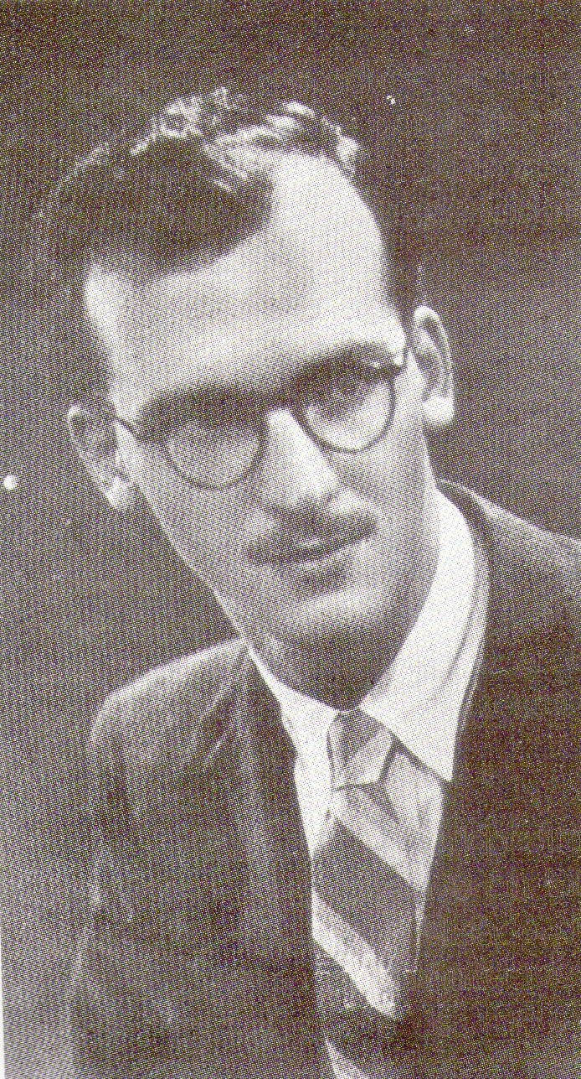

Bentín Diez Canseco, José, *Enrique Seoane Ros una búsqueda de raíces peruanas,* Editorial imprenta Desa S.A.1989

Enrique Seoane Ros, peruvian architect, born in Lima on January 12, 1915, from his childhood reflects a sensitivity to art through drawing and painting, as teenager he will be marked by the trip he made to the city of Arequipa, where the context will influence their way of perceiving architecture. Seoane Immaculate continued his architectural studies at the School of Engineer on Lima culminating in 1938. During his parallel studies he conducted a pre-professional training in the studio of architect Payet after the Calderon Alvarez architects and Harth Terre. In 1939, he worked for the firm Gramonvel, where it relates to the neoclassical style that was in vogue, but his creativity, sensitivity, and the search for identity of Peruvian architecture in his work led him to quickly gain fame. In 1944 obtains the title of Engineer-Architect and began his career independently. His work as a teacher began in 1945, at the National School of Engineers, culminating in 1957 in the other hand, Seoane Wins a National Award "Chavin" twice (1950 and 1953), by The Phoenix and Ostolaza buildings respectively. Then in 1973 he traveled to Panama where Diaz worked in construction and physical planning consulting professor and researcher at the University of Panama but due to health problems returns to the city of Lima in 1975 where he resumed his work as a teacher to his last days at the University Federico Villareal. Seoane died on July 26, 1980.

Seoane architecture refers to the plastic sense of Peruvian architecture, where amalgamate traditional and modern architecture. Seoane means a transition to the modern neo-colonial style and in his later years to an emerging postmodern style. The importance of his work as an architect during this process was the constant search for identity Peruvian architecture, which could be nourished with modern architecture or the international architecture, but not lose its essence in the local as reference source.

Adapting to changes, achieving reach customers and convince them of his design were skills that Seoane had ,and his architectural output was vast, resulting from single family homes to high class and later for smaller houses, as well in hotels, banks and public and private buildings. Seoane was one of the most important Peruvian architects and influential architecture in Peru, but spontaneous and independent character although he did participate on a theoretical group as the "Space Group".

In his work as an architect is recognized four periods in his works.

The first period between the years 1939-1945, where Seoane's work forming part of a neocolonial style based on a Neoperuano Spanish sculptor Manuel Piqueras, who rescued pre-Inca Inca items throughout  his works, Seoane evolves this style with a more sculptural and plastic essence, use clean volumes with breaks or joints between them, working on them he also elaborated the rounding of the edges, coronations, cornices, railings and walls with textures rescued from pre-Inca cultures, Inca. At this stage Seoane still support his teacher and architect Velarde, who praised his work in seeking the convergence of the traditional architecture of Peru and the influence that led from outside the country, modern architecture, further indicating that together with Alejandro Alva constitute the last link in the neocolonial architecture. Within this stage the most representative works are: The Building Rizo Patron, the Hotel Miramar.

The second stage of the architecture of Seoane was between 1946-1950, where it marks the transition from neo to modern. Modern architecture is introduced to Peru in mid-1940, exerted influence on Seoane, the use of formal elements decorative and stylized neo were not neglected but the interest in documenting these items no longer lay in formal stylizations but rather framed rescued rationalism in the traditional style of the pre Inca architecture, the   Inca and colonial eg the hallway, the patio, the platforms, the first level of elevation, among others. Seoane This approach to modern architecture is related to the beginning of his work as a teacher in the School of Engineering, where shared conversations and discussions with architects founders of the "Group Space" theory group that introduced modern architecture to Peru . Seoane not get to belong to this group because their interest lay in the architecture to the architecture, an example of this stage is the Wilson Building.

The third stage comprises between 1946-1970, parallel to the second stage, where the interest in modern architecture is higher because not only a didactic but concrete at this stage will be found in the works of formal elements Seoane neocolonial style of architecture had much more stylized and rationalist ideas, Seoane will show proficiency in the relationship of interior spaces, fluid and hierarchization them depending on usage. Symmetry used in plants, clean volumes elevating the first floor, as seen in Phoenix Building. It is at this stage where the work of Seoane has more recognition, this transition in his work gave him a personal stamp on their architecture, being recognized by many architects, students and clients. Between 1951-1960, Seoane office becomes the first to formalize the representation plane technique modern architecture in Peru, because of this many talented architects passed through his office, architects such as Adolfo Cordova, Carlos Williams, Hans Gunther, Walter Weberthofer, Bryce José García, Javier Key, Miguel Angel Llona, among others. The intent of the architecture of Seoane at this time was to make contemporary architecture but also including peruanista content.

The fourth stage was between 1971-1980, where he presented glimpses of a transition to postmodernism. It consolidates rationalism (simplicity of form, expression of structure and function) but also will seek new architectural trends (neo-brutalism and neo-expressionism), is a mixture of sobriety with the expression and the degree of technological-functional. At this stage Seoane culminate many works, some of them in the center of the city of Lima, where you can see the management of its architecture with the environment, Seoane was one of the few architects who managed the transition of the old with the modern, their great handling of the scale, the use of the basement floors as volume achieved the integration of the city buildings. His experience working in Panama influenced him toward neobrutalismo and neo-exresionismo, that in the city of Lima was reflected in the Hotel Cesar's.

In the four periods there is a search for identity in architecture, where not only has the plasticity of the work but also the technology and the functional. Enrique Seoane is one of the few that gave identity architects Peruvian architecture.

LIST OF WORKS

FIRST STAGE

1939-40 Building Rizo Patron, Lima

1939-43 Estate Huando

1943-44 Church of Ancon

SECOND STAGE

1945-46 Building Nazarene Tacna, Lima.

1945-46 Wilson Building, Historic Centre of Lima, Lima.

THIRD STAGE

1945-48 The Phoenix Building, Historic Centre of Lima, Lima.

1947-48 The Insurance Company Building National Historic Centre of Lima, Lima.

1951-53 Ostolaza Building, Historic Centre of Lima, Lima.

1951-56 Ministry of Education, Historic Centre of Lima, Lima.

1952-53 Houses Brescia, San Isidro, Lima.

1952-53 Leon Pinelo College, San Isidro, Lima.

1952-54 Building Diagonal, Miraflores, Lima.

1953-54 Residential Limatambo. San Isidro, Lima.

1953 Pilar Church, Arequipa.

1957-65 Colegio Santa María, Monterrico, Lima.

1957-65 Banco Wiese, Historic Centre of Lima, Lima.

FOURTH STAGE

1971-74 Cesar’s Hotel, Miraflores, Lima.

1973-74 Mariana Torres Building, Panamá.

**References:**

Bentín Diez Canseco, José (1989). *Enrique Seoane Ros, una búsqueda de raíces peruanas.* Lima: [Facultad de Arquitectura](http://es.wikipedia.org/wiki/Facultad_de_Arquitectura,_Urbanismo_y_Artes_(UNI,_Per%C3%BA)" \o "Facultad de Arquitectura, Urbanismo y Artes (UNI, Perú)) de la [Universidad Nacional de Ingeniería](http://es.wikipedia.org/wiki/Universidad_Nacional_de_Ingenier%C3%ADa_(Per%C3%BA)" \o "Universidad Nacional de Ingeniería (Perú)).

<http://blog.pucp.edu.pe/item/115913/arquitectura-y-arquitectos-en-lima-enrique-seoane-ros>

**Visual material:**

**FIRST STAGE**

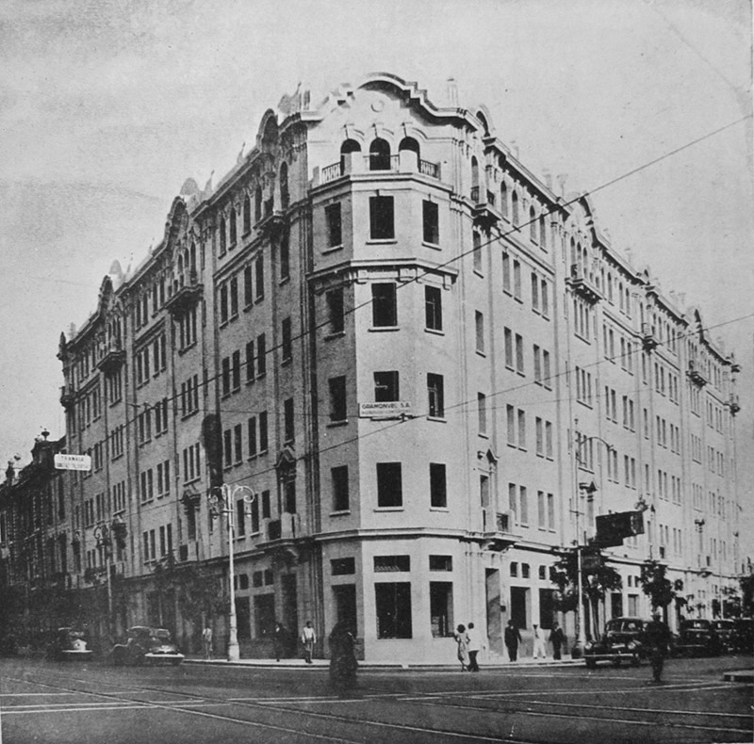

Building Rizo Patron, Lima, 1940

<http://www.skyscrapercity.com/showthread.php?p=103585144>

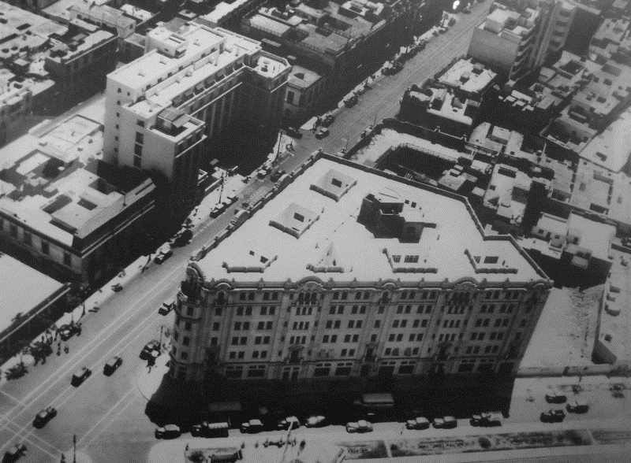

Building Rizo Patron, Lima, 1940

<http://www.skyscrapercity.com/showthread.php?p=103585144>

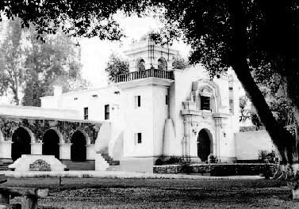

Estate Huando, Huaral, 1943

<http://dehuaral.com/tag/casa-hacienda-huando/>

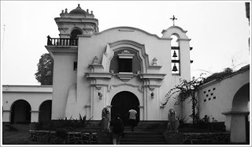

Church of Ancon, 1944

<http://elveleroazul.blogspot.com/2009/11/arquitecto-peruano-enrique-seoane-ros.html>

**SECOND STAGE**

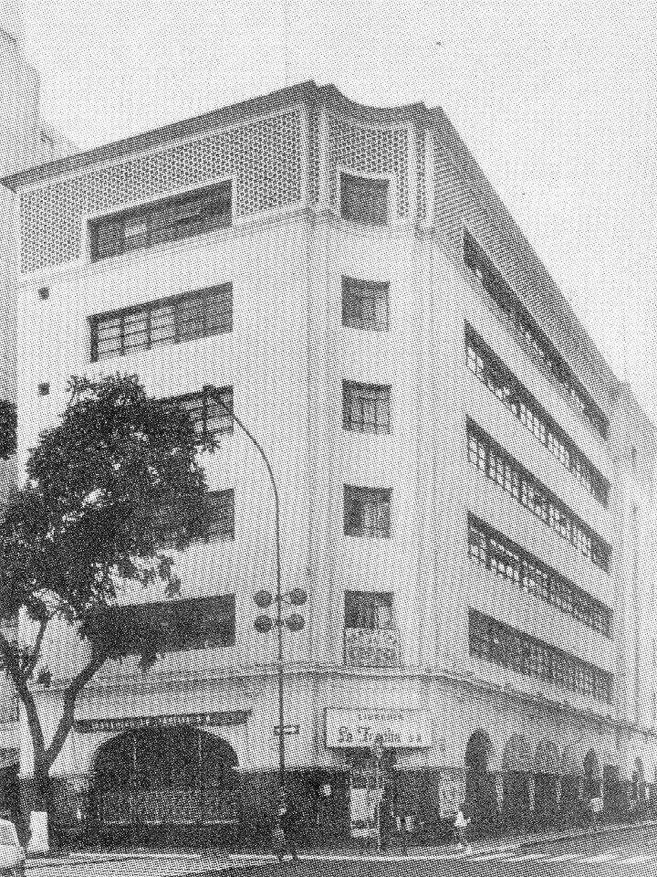

Building Nazarene Tacna, Lima, 1946

Source: Bentín Diez Canseco, José, *Enrique Seoane Ros una búsqueda de raíces peruanas,* Editorial imprenta Desa S.A.1989

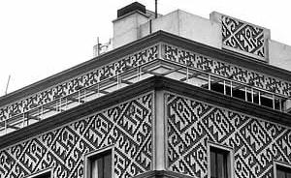

Wilson Building, Historic Centre of Lima, Lima, 1946.

<http://www.vitruvius.com.br/revistas/read/arquitextos/04.041/648>

**THIRD STAGE**

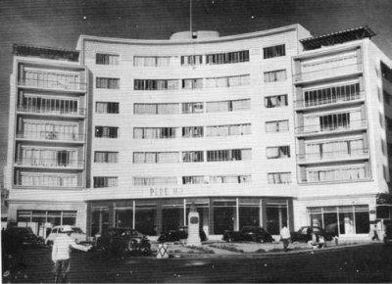

The Phoenix Building, Historic Centre of Lima, 1948.

<http://www.google.com.pe/imgres?imgurl=http://blog.pucp.edu.pe/media/1987/20101107-fenix.jpg&imgrefurl=http://blog.pucp.edu.pe/item/115913/arquitectura-y-arquitectos-en-lima-enrique-seoane-ros&usg=__eGFnUmE0AKCJZIGfpeN9Jz9-Yn8=&h=290&w=400&sz=32&hl=es&start=8&zoom=1&tbnid=3YetKDn0kv_apM:&tbnh=90&tbnw=124&ei=3bvuUd3_J5HwrAGV6IHgDA&prev=/images%3Fq%3Denrique%2Bseoane%26sa%3DX%26rlz%3D1T4GGIE_enPE427%26hl%3Des%26tbm%3Disch&itbs=1&sa=X&ved=0CDgQrQMwBw>

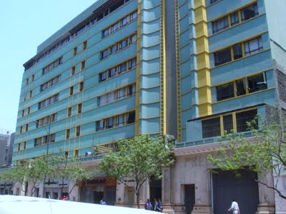

The Insurance Company Building National Historic Centre of Lima, Lima,1948.

Copyright: Jorge Villavisencio

<http://jvillavisencio.blogspot.com/2009/11/enrique-seoane-ros-arquitecto-peruano.html>

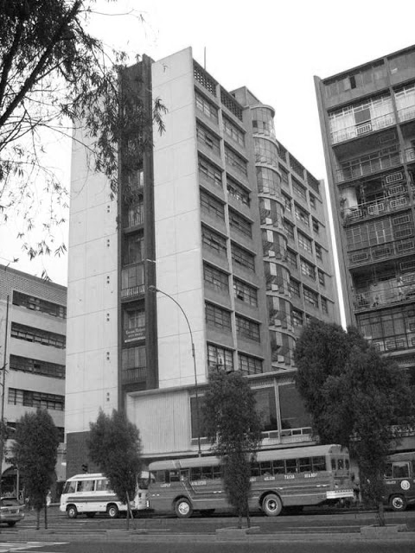

Ostolaza Building, Historic Centre of Lima, Lima, 1953

<http://limalaunica.blogspot.com/2011/02/la-misteriosa-casa-del-sr-trayon.html>

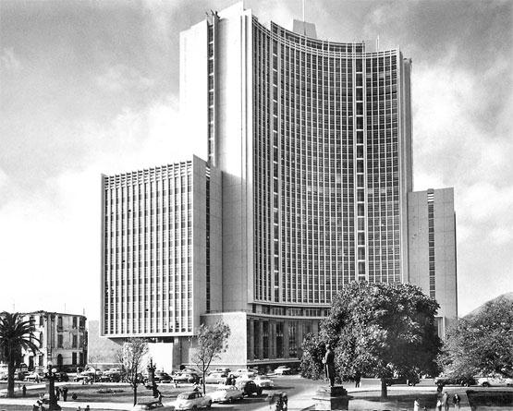

Ministry of Education, Historic Center of Lima, 1956.

<http://terusblog-upc.blogspot.com/2009/11/enrique-seoane.html>

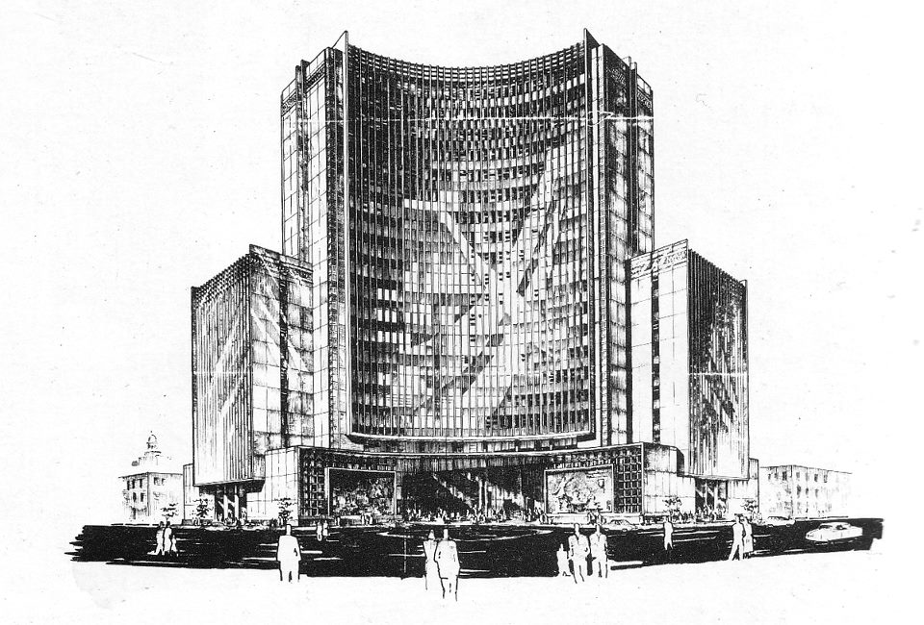

Ministry of Education, Historic Center of Lima, 1956.

<https://www.facebook.com/apuntesdarquitectura>

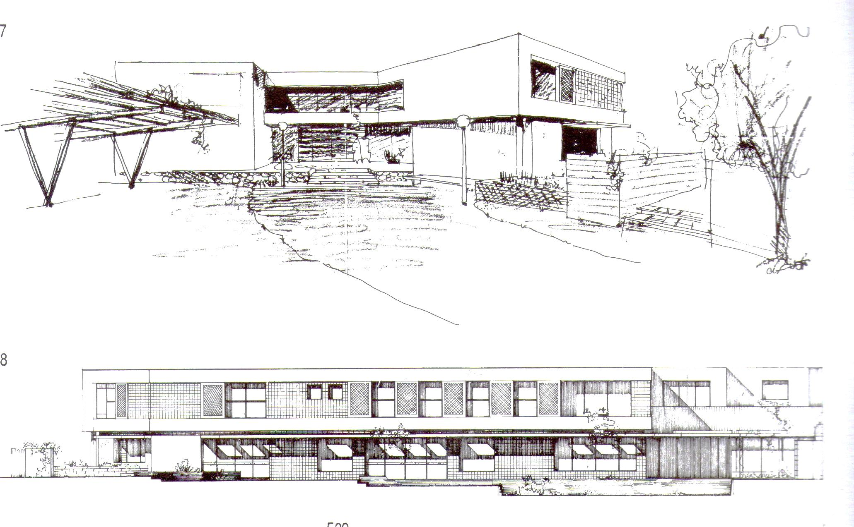

Houses Brescia, San Isidro, Lima.

Source: Bentín Diez Canseco, José, *Enrique Seoane Ros una búsqueda de raíces peruanas,* Editorial imprenta Desa S.A.1989

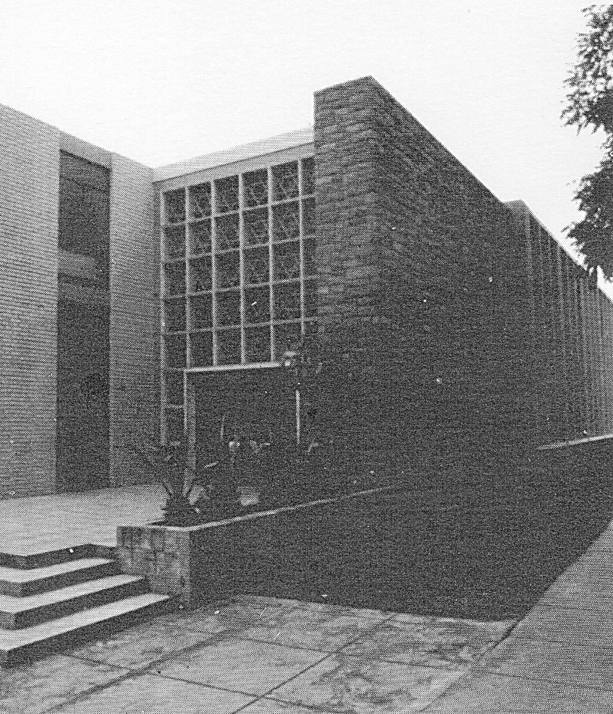

Leon Pinelo College, San Isidro, Lima, 1953

Source: Bentín Diez Canseco, José, *Enrique Seoane Ros una búsqueda de raíces peruanas,* Editorial imprenta Desa S.A.1989

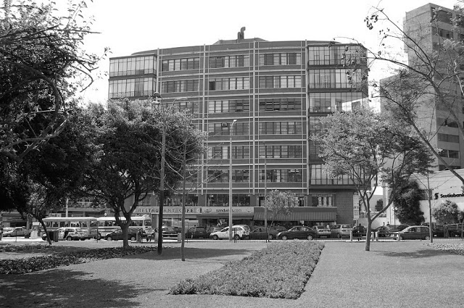

Building Diagonal, Miraflores, Lima, 1954.

<http://www.google.com.pe/imgres?imgurl=http://1.bp.blogspot.com/-yfsAOH7xINY/TdWH46vu1wI/AAAAAAAABIk/X7ETNW1cISw/s640/Guzm%2525C3%2525A1n%252BBlanco%252B1952.%252BArq.%252BVillar%2525C3%2525A1n.jpg&imgrefurl=http://laformamodernaenlatinoamerica.blogspot.com/2013/04/praxis-de-la-arquitectura-multifamiliar.html&usg=__BiKPvnbeD2cibRtcrYqYZK9IGJQ=&h=400&w=640&sz=90&hl=es&start=10&zoom=1&tbnid=VzRKBoMiC66UvM:&tbnh=86&tbnw=137&ei=VMDuUeLpF5SrrgHZ1YHADQ&prev=/images%3Fq%3Denrique%2Bseoane%2Bedificio%2Bdiagonal%26rlz%3D1T4GGIE_enPE427%26hl%3Des%26tbm%3Disch&itbs=1&sa=X&ved=0CDwQrQMwCQ>

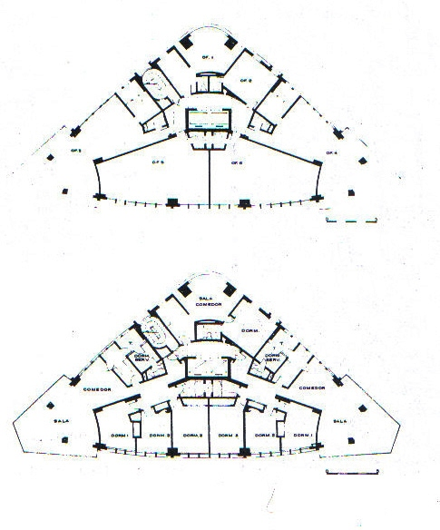

Building Diagonal, Miraflores, Lima, 1954.

<http://www.google.com.pe/imgres?imgurl=http://2.bp.blogspot.com/-TYiQRTqBiMM/Tr_mZH2UpkI/AAAAAAAABEk/ff5HLddmP3A/s320/F.005%252B-%252BPlanta%252BBaixa%252BEdif.%252BDiagonal%252B-%252BFonte%252BBent%2525C3%2525ADn%252B1989.jpg&imgrefurl=http://jvillavisencio.blogspot.com/2011_11_01_archive.html&usg=__JaSbCv6PE2cz2_4cxFMNF6b3TLY=&h=584&w=485&sz=125&hl=es&start=28&zoom=1&tbnid=kaZlbtg8WQ10-M:&tbnh=135&tbnw=112&ei=gcHuUcOMGIf6qAH3yYGgCw&prev=/images%3Fq%3Denrique%2Bseoane%2Bedificio%2Bdiagonal%26start%3D20%26sa%3DN%26rlz%3D1T4GGIE_enPE427%26hl%3Des%26tbm%3Disch&itbs=1&sa=X&ved=0CDgQrQMwBzgU>

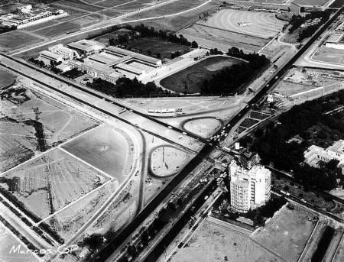

Residential Limatambo. San Isidro, Lima, 1954.

<http://www.google.com.pe/imgres?imgurl=http://blog.pucp.edu.pe/media/1987/20101107-fenix.jpg&imgrefurl=http://blog.pucp.edu.pe/item/115913/arquitectura-y-arquitectos-en-lima-enrique-seoane-ros&usg=__eGFnUmE0AKCJZIGfpeN9Jz9-Yn8=&h=290&w=400&sz=32&hl=es&start=8&zoom=1&tbnid=3YetKDn0kv_apM:&tbnh=90&tbnw=124&ei=3bvuUd3_J5HwrAGV6IHgDA&prev=/images%3Fq%3Denrique%2Bseoane%26sa%3DX%26rlz%3D1T4GGIE_enPE427%26hl%3Des%26tbm%3Disch&itbs=1&sa=X&ved=0CDgQrQMwBw>

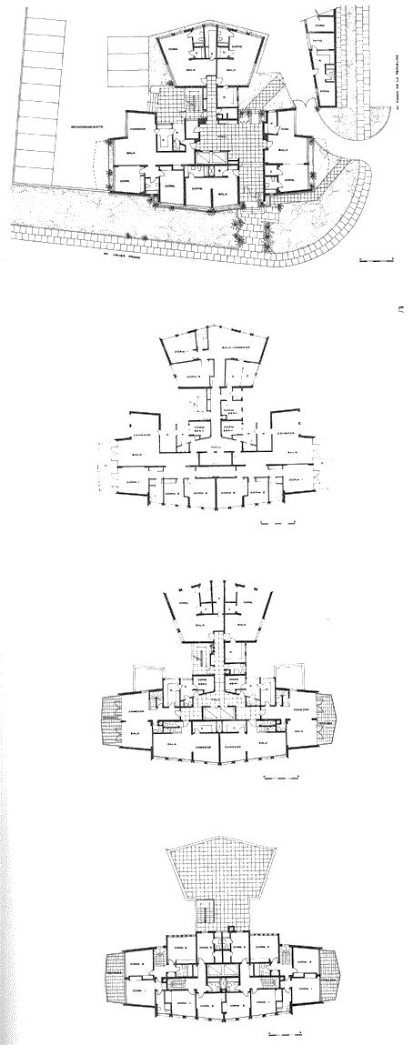

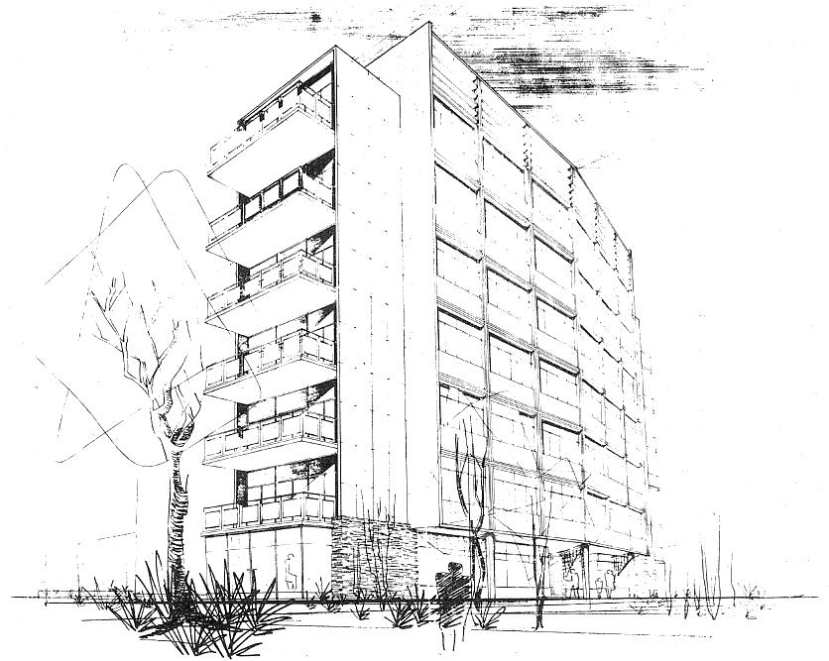

Residential Limatambo. San Isidro, Lima, 1954.

<http://www.google.com.pe/imgres?imgurl=http://4.bp.blogspot.com/-k3qCSJZj3pY/T4Jmszvhl4I/AAAAAAAACPs/xtB2qQmiqIs/s320/2012-04-08%2BLimatambo%2B03.jpg&imgrefurl=http://divagarquitectura.blogspot.com/2012/04/residencial-limatambo-in-memoriam.html&usg=__P_4oBwdqiBMHV1oC_8CW7HE_Q-Y=&h=320&w=238&sz=31&hl=es&start=42&zoom=1&tbnid=l2X9SQAigZnqlM:&tbnh=118&tbnw=88&ei=ocLuUcjgI8jVqQGfjID4AQ&prev=/images%3Fq%3Denrique%2Bseoane%2Bedificio%2Bdiagonal%26start%3D40%26sa%3DN%26rlz%3D1T4GGIE_enPE427%26hl%3Des%26tbm%3Disch&itbs=1&sa=X&ved=0CCwQrQMwATgo>

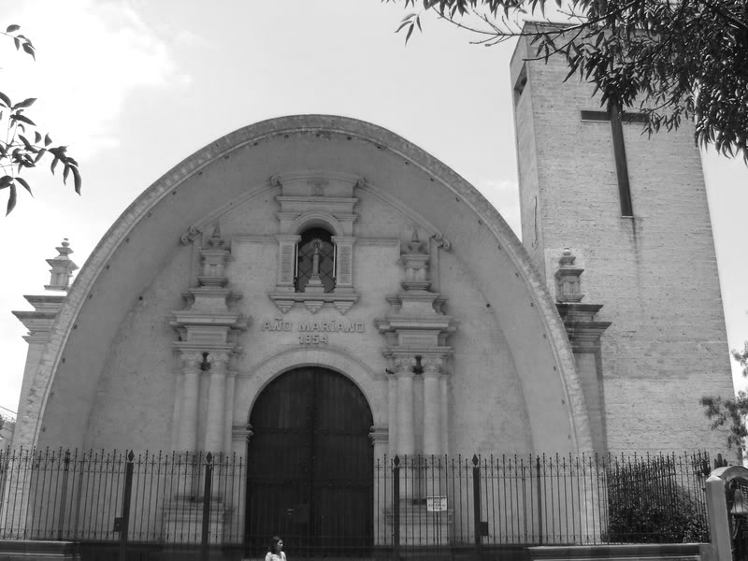

Pilar Church, Arequipa.

<http://www.skyscrapercity.com/showthread.php?t=584057>

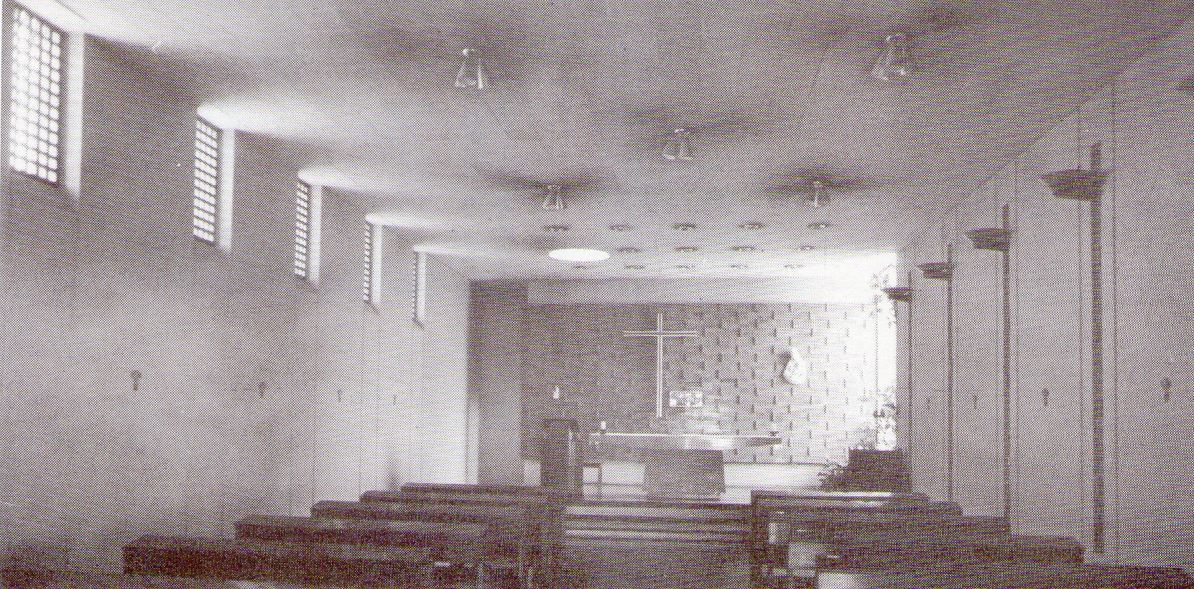

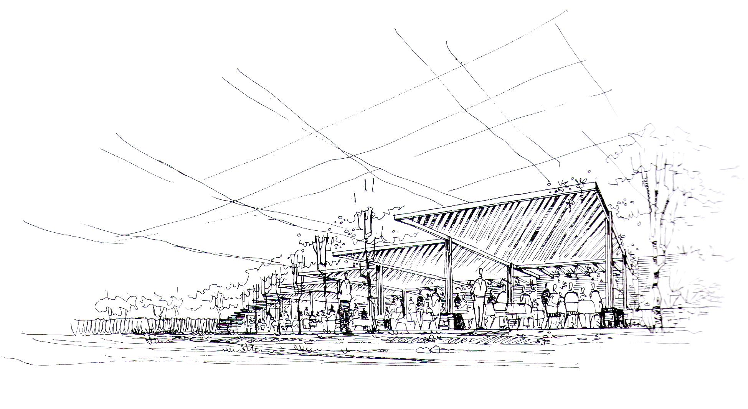

Colegio Santa María, Monterrico, Lima, 1965

Source: Bentín Diez Canseco, José, *Enrique Seoane Ros una búsqueda de raíces peruanas,* Editorial imprenta Desa S.A.1989

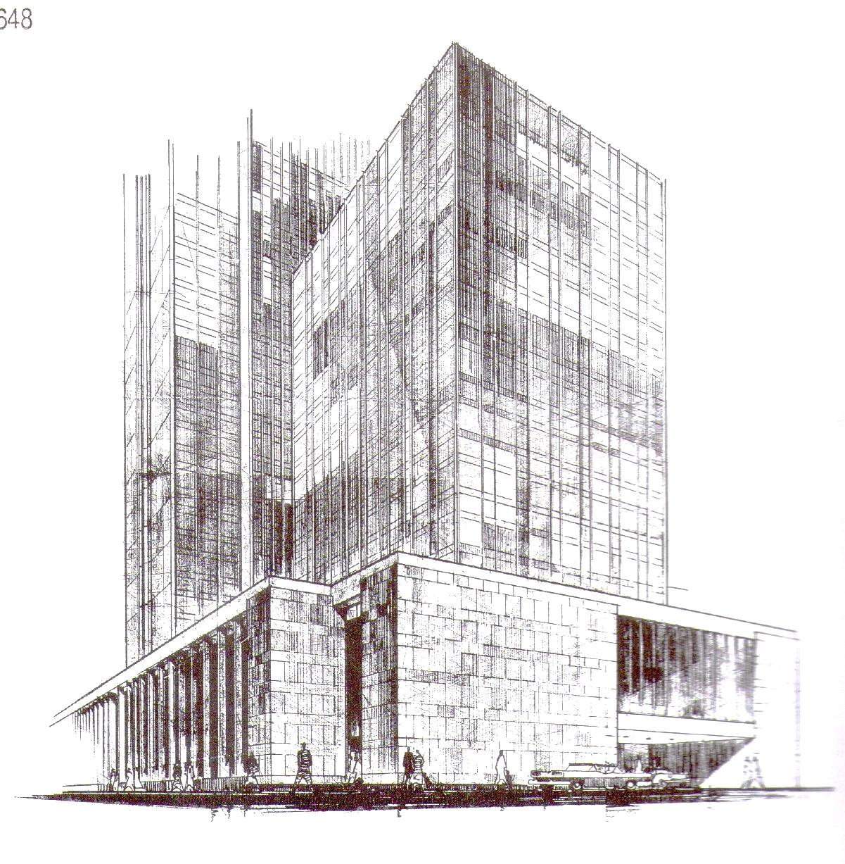

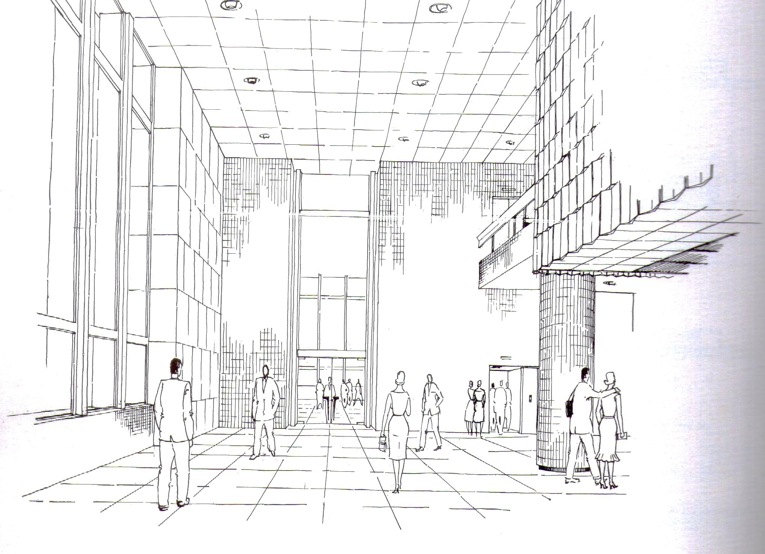

Banco Wiese, Historic Centre of Lima, Lima,1965

Source: Bentín Diez Canseco, José, *Enrique Seoane Ros una búsqueda de raíces peruanas,* Editorial imprenta Desa S.A.1989

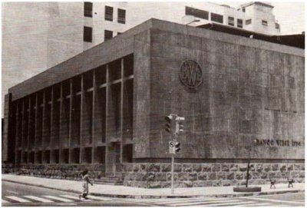

Banco Wiese, Historic Centre of Lima, Lima,1965

<http://cybertesis.upc.edu.pe/upc/2004/shell_ma/html/TH.3.html>

**FOURTH STAGE**

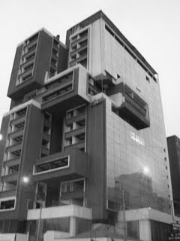

Cesar’s Hotel, Miraflores, Lima,1974

<http://hebertasayco1277.blogspot.com/2010/06/enriqeu-seoane-ros.html>

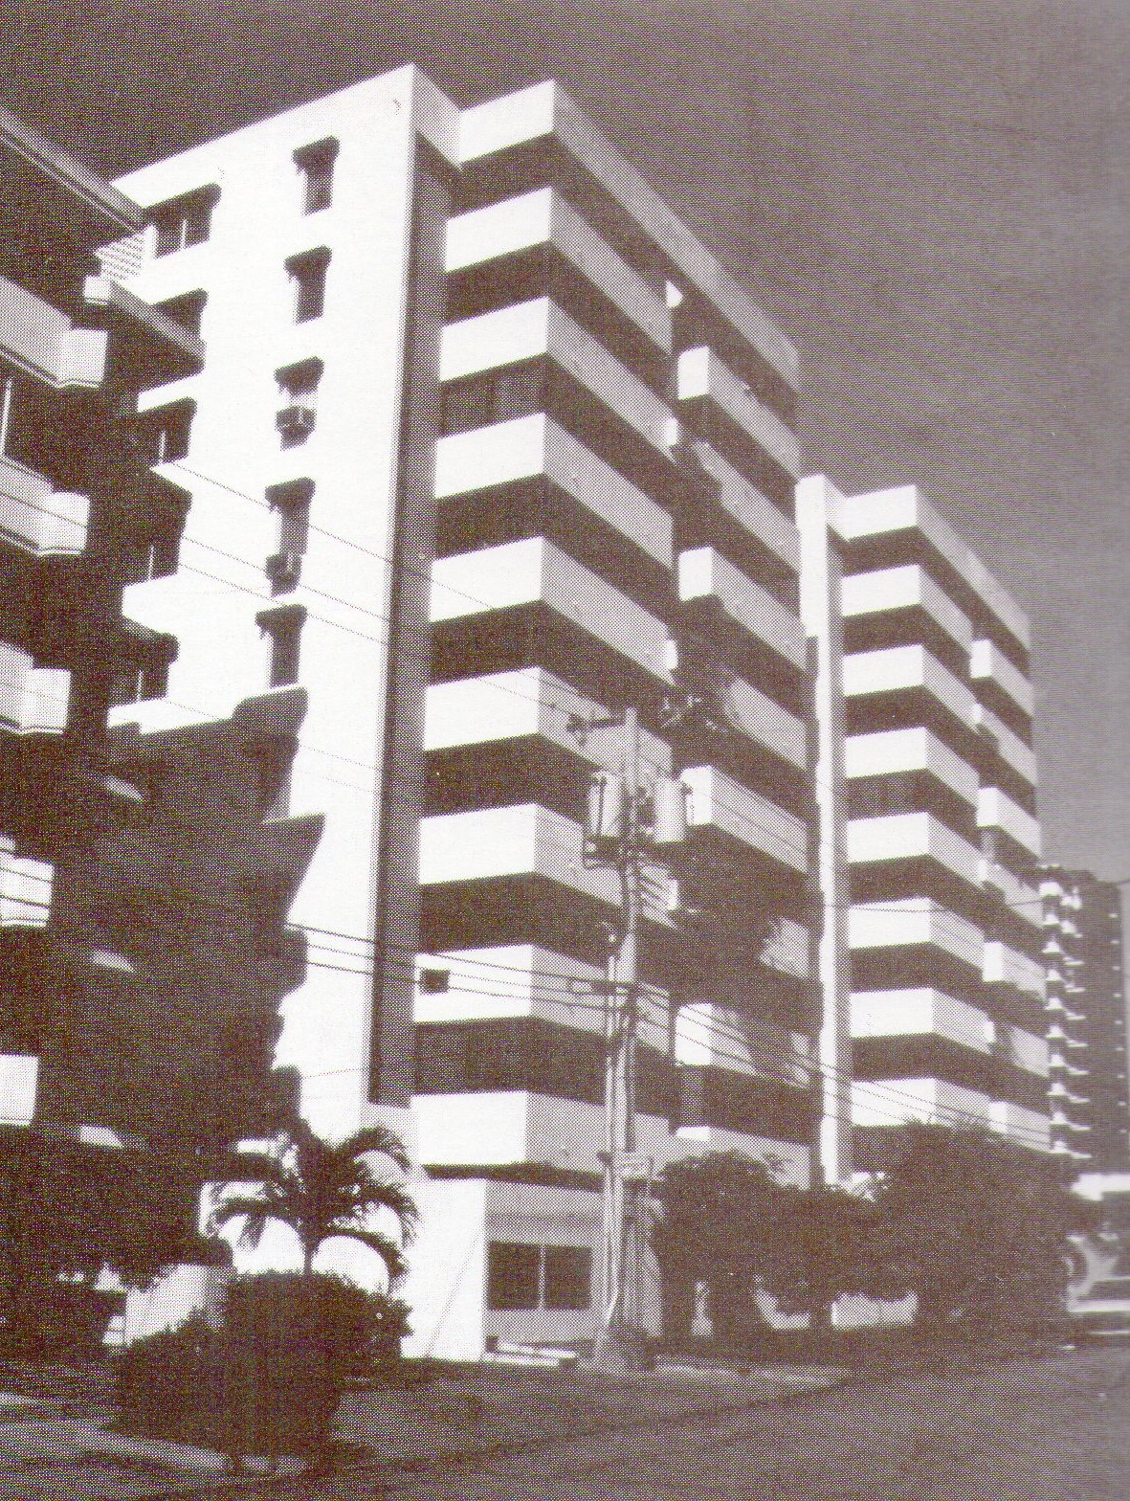

Mariana Torres Building, Panamá, 1974.

Source: Bentín Diez Canseco, José, *Enrique Seoane Ros una búsqueda de raíces peruanas,* Editorial imprenta Desa S.A.1989